**Table of Contents**

1. Abstract
2. Introduction
3. Carbon Flux and Its Importance
4. Stokes Law and Predicting Sinking Speeds  
   A. Global Maps of Important Environmental Variables that are measured by satellite (T, S, μ)  
   B. Particle Size and Sinking Speed Estimates  
   C. Particle Size Distribution and Global Carbon Flux Estimates
5. Sediment Trap Data
6. Comparisons Between Data
7. Discussion
8. Citations

**Abstract**

The abstract will outline the essential topics of the thesis and condense it into a short and digestible package.

**Introduction**

The introduction will give background to the paper, reference relevant papers (Kostadinov et. al 2009, 2016, MIT Seawater Papers, Mouw Dataset), as well as stating the main points of the thesis: The mathematical concepts of Stokes Law (force balance between gravity and the friction of the fluid), satellite data and its resulting plots, comparisons sediment trap data. It will also outline the general structure for the paper.

**Carbon Flux and Its Importance**

Carbon is exchanged between many systems throughout the world. It is important to understand how carbon flows within and throughout a system in order to draw a more versatile picture of the global carbon balance. Carbon flux is a description of the amount of carbon that flows in and out of a system, which can help us both understand the size of the reservoir and the amount of exchange between different systems. Estimating carbon export within the ocean is difficult, and although many theories and estimates are presented, there does not exist an extremely accurate and widely agreed upon model. Furthermore, estimating carbon export is difficult as available data is heavily restricted by spatial and temporal constraints. Thus, generating an estimate of carbon export within the ocean using data gathered solely from one source is a desirable objective. Satellite data is very valuable as a large amount of data can be collected over long periods of time without in-field measurements.

A pathway to generating an estimate of the carbon export within the ocean is to first estimate the sinking speed of particles. Carbon export is linked to the biomass traveling to the bottom of the seafloor, as phytoplankton fix carbon and sink to the ocean floor, exporting carbon.

**Stokes Law and Predicting Sinking Speeds**

Sinking speeds of phytoplankton are often estimated by Stokes’ law, which predicts sinking velocities that scale by an exponent of 2 in relation to its radius. Sinking plankton particles satisfy the prerequisites of Stokes’ Law, as they are small, slow moving spherical objects that move slowly in relation to its outside medium. Using A newer model predicts that diatoms, which synthesize approximately half of the ocean’s fixed carbon (Nelson et al 1995; Field et al 1998, cited within Miklasz et al 2010), may follow a more complex extended Stokes Law that accounts for the differing densities of diatomic components (Miklasz and Denny 2010).

The classic stokes model predicts that a sinking particle’s speed (U) is:

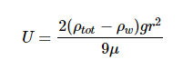

Where ρtot is the density of the particle, ρw is the density of the surrounding liquid (in this case water), r is the radius of the particle, g is the constant of gravitational acceleration (9.8 m s-2), and μ is the dynamic viscosity of surrounding liquid (water).The extended model presented by Miklasz and Denny (2010) assumes constants of ρw = 1023 kg m-3 and μ = 1.07 x 10-3 Pa s, which represents the density and dynamic viscosity of water at 20°C and 33 g L-1 salinity, respectively. Stokes’ law holds up for particles with small Reynolds numbers (Re < 1), which encompasses all particles mentioned in this paper. Since both dynamic viscosity and water’s density varies with temperature and salinity, it is important to consider both variables within our calculation. However, because the range at which water’s density varies with respect to temperature and salinity differences is so small, we can safely assume water to have a constant density of ρw ≈ 1023 kg m-3. Since dynamic viscosity is a large factor in this equation (*need to write state why*), we include the variation of dynamic viscosity within our calculation. In order to calculate the change in dynamic viscosity, we use a seawater toolbox that estimates dynamic viscosity of seawater given temperature and salinity (Sharqawy et al 2010).

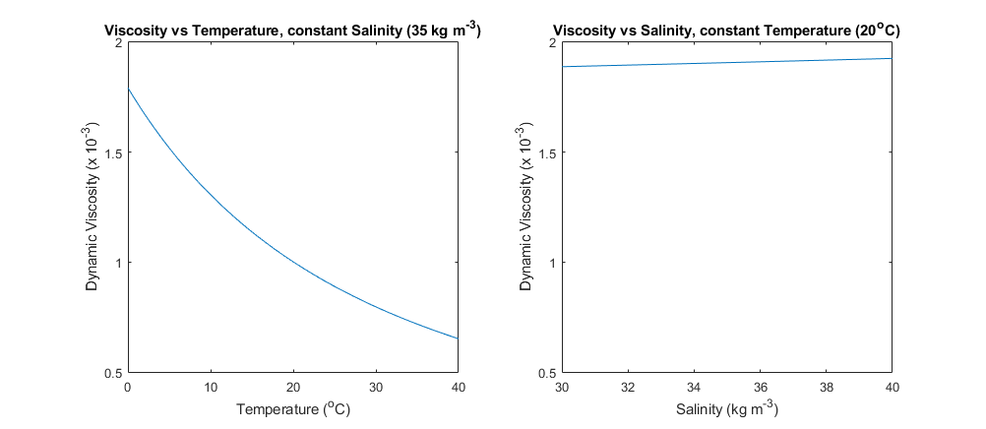

**Figure 1:** Variation in Dynamic Viscosity of Seawater (μ). Viscosity is plotted against temperature, while holding salinity constant at 35 kg m-3 (left). Viscosity is also plotted against salinity, while holding temperature constant at 20oC.

**(viscosityplot.m)**

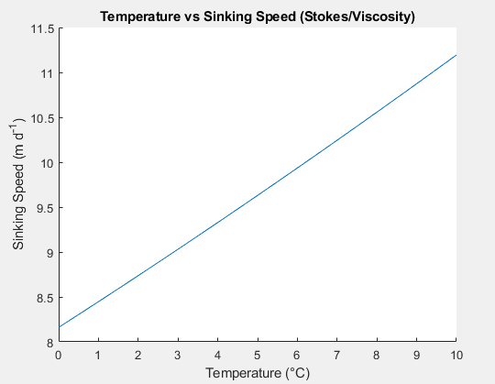

**(SpeedPlot_Viscosity_Density_Temperature.m)**

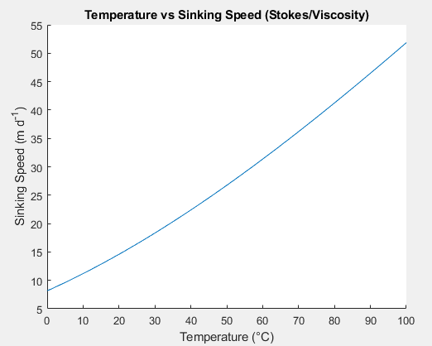

**(SpeedPlot_Viscosity_Density_Temperature.m)**

1. Global Maps of Important Environmental Variables that are measured by satellite (T, S, μ)

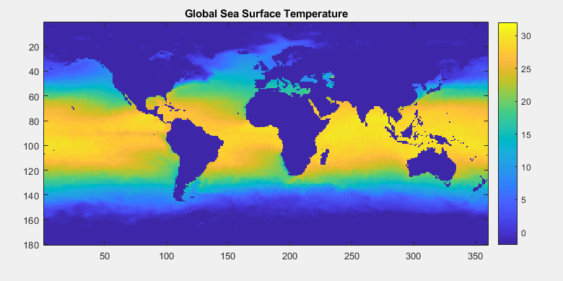

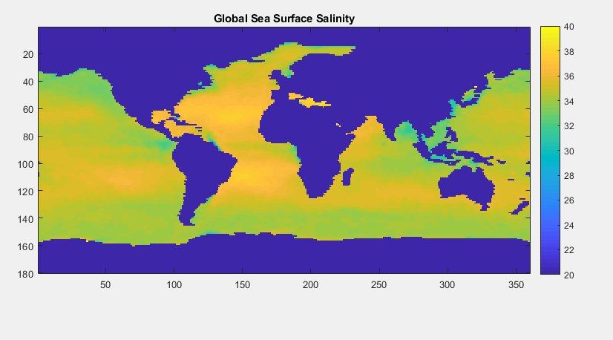

(C_biomass.m)

B. Particle Size and Sinking Speed

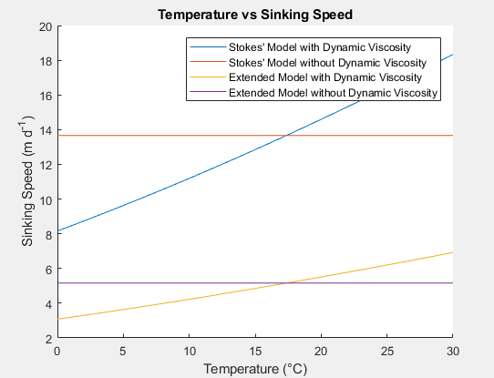

**(StokesDennysPlot.m)**

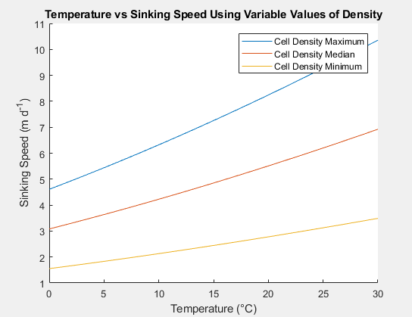

**(VariableDensity.m)**

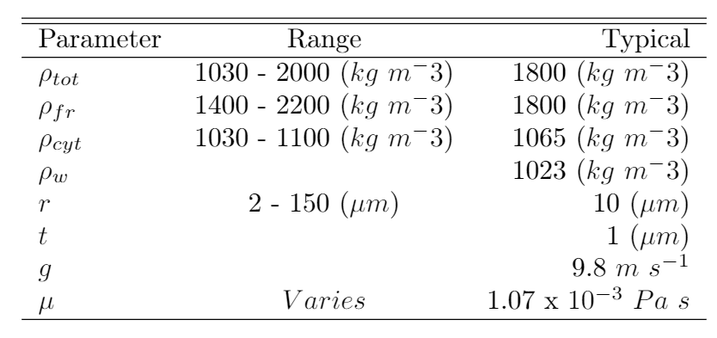

**(LaTeX doc)**

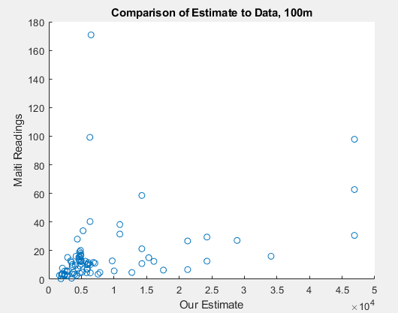

C. Particle Size Distribution and Global Carbon Flux Estimates

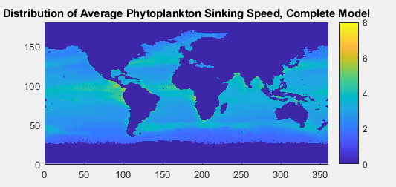

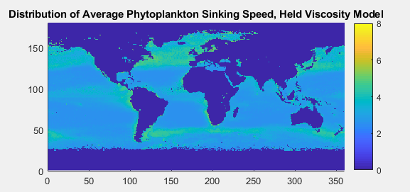

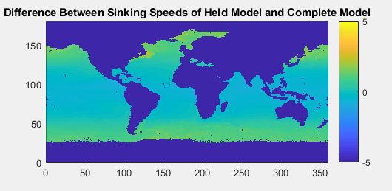

(SinkingSpeedScriptComplete.m)

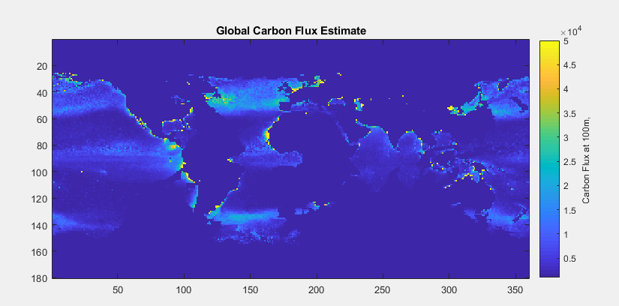

(C_Biomass.m)

**Sediment Trap Data**

**Comparisons Between Data**

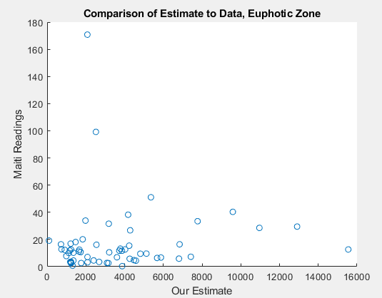

(C_biomass.m)

**Discussion**

**Citations**

Kostadinov, T. S., Siegel, D. A., & Maritorena, S. (2009). Retrieval of the particle size distribution from satellite ocean color observations. Journal of Geophysical Research, 114(C9). <https://doi.org/10.1029/2009jc005303>

Kostadinov, T. S., Milutinovic, S., Marinov, I., & Cabré, A. (2016). Size-partitioned phytoplankton carbon concentrations retrieved from ocean color data, links to data in NetCDF format, supplement to: Kostadinov, Tihomir S; Milutinovic, Svetlana; Marinov, Irina; Cabré, Anna (2016): Carbon-based phytoplankton size classes retrieved via ocean color estimates of the particle size distribution. Ocean Science, 12(2), 561-575 [Data set]. PANGAEA - Data Publisher for Earth & Environmental Science. <https://doi.org/10.1594/pangaea.859005>

Nayar, K. G., Sharqawy, M. H., Banchik, L. D., & Lienhard V, J. H. (2016). Thermophysical properties of seawater: A review and new correlations that include pressure dependence. Desalination, 390, 1–24. <https://doi.org/10.1016/j.desal.2016.02.024>

Sharqawy, M. H., Lienhard V, J. H., Zubair, S. M. (2010). Thermophysical Properties of seawater: A review of existing correlations and data. Desalination and Water Treatment, 16, 354-380.

<http://web.mit.edu/lienhard/www/Thermophysical_properties_of_seawater-DWT-16-354-2010.pdf>